Domain Name Service

How the DNS works?
Each computer connected to the internet has a numeric code called an IP address. We can imagine the IP address as a phone number. Numbers are difficult for people to remember that’s why Domain Names were created to convert the numeric address into simple, recognizable names.

On the Internet, these domain names, such as
http://www.cisco.com
are much easier for people to remember than
198.133.219.25
which is the actual numeric address for this server.

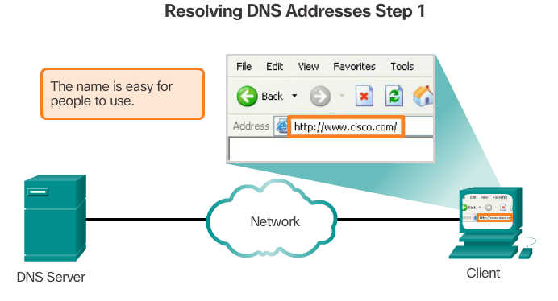

The system translates easy to remember names (domain names) into numbers (IP addresses)
A computer must first recognize the IP address of the server, which hosts the requested web page. Locating of the IP address is processed through DNS serves.
The DNS protocol defines an automated service that matches resource names with the required numeric network address. It includes the format for queries, responses and data. The DNS protocol communications use a single format called a message. This messages format is used for all types of client queries and server responses, error messages, and the transfer of resource record information between servers.
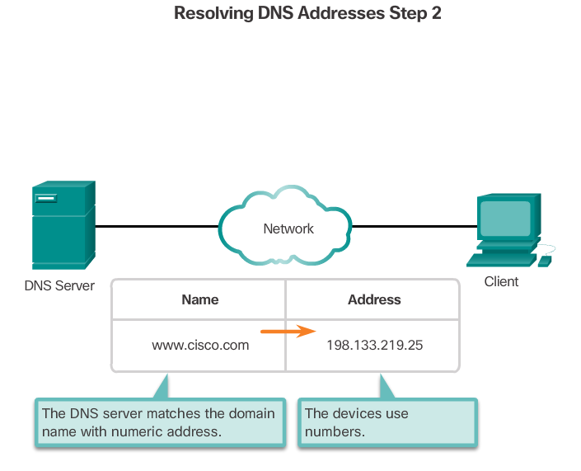
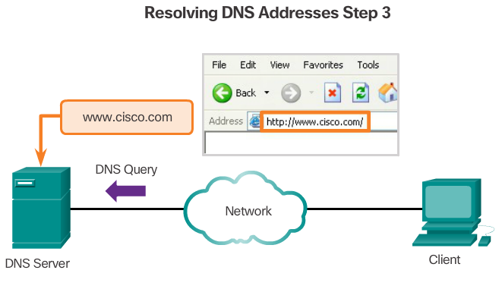
A computer (client) is sending to DNS queries to get the IP address of the resource name
The client visits one of the root DNS servers. There are 13 of these servers in the world. Each of them is multiply protected. The client will always choose the closest one. The local DNS server doesn’t know the IP address, but it knows which server to ask for an IP address in the domain.

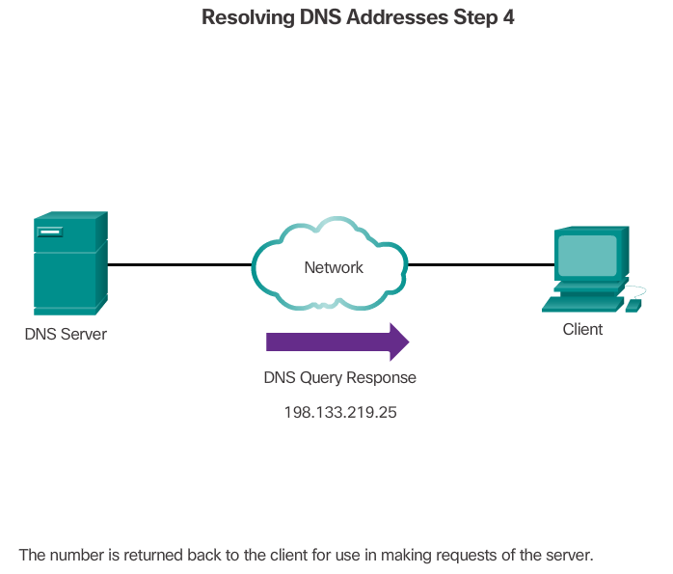

DNS Hierarchy www.cisco.com
The DNS protocol uses a hierarchical system to create a database to provide name resolution. The hierarchy looks like an inverted tree with the root at the top and branches below (see the figure). DNS uses domain names to form the hierarchy.
The different top-level domains represent either the type of organization or the country of origin. Examples of top-level domains are:
- .com - a business or industry
- .org - a non-profit organization
- .au - Australia
- .co - Colombia

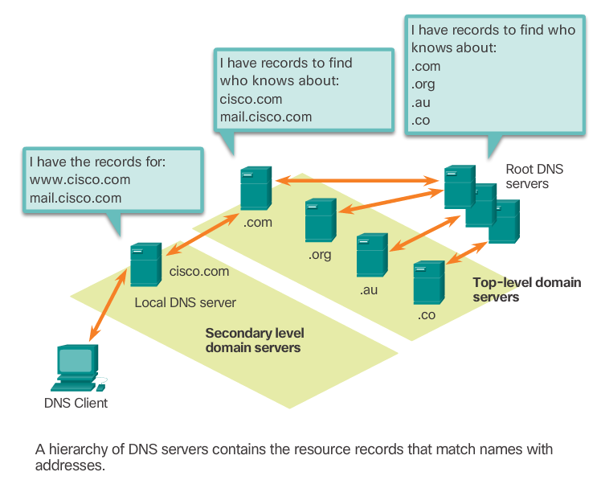

1. Questions:

- Why was Domain name created?
- What does the DNS protocol define?
- What does the protocol include?
- What does DNS use to form the hierarchy?
- How does the hierarchy look like?
- Give the examples of the top level domains.

2. Complete the text with the correct words. There is one word that you won’t use.

Convert, numeric, works, recognizable, phone number hierarchy

How the DNS ?
Each computer connected to the internet has a code called an IP address. We can imagine the IP address as a . Numbers are difficult for people to remember that’s why Domain Names were created to the numeric address into simple, names.

